**Prospective international students worried about federal government caps**

**[By Natasya Salim, Oscar Coleman](https://www.abc.net.au/news/natasya-salim/12187144)**

**Posted Fri 30 Aug 2024 at 4:59am**

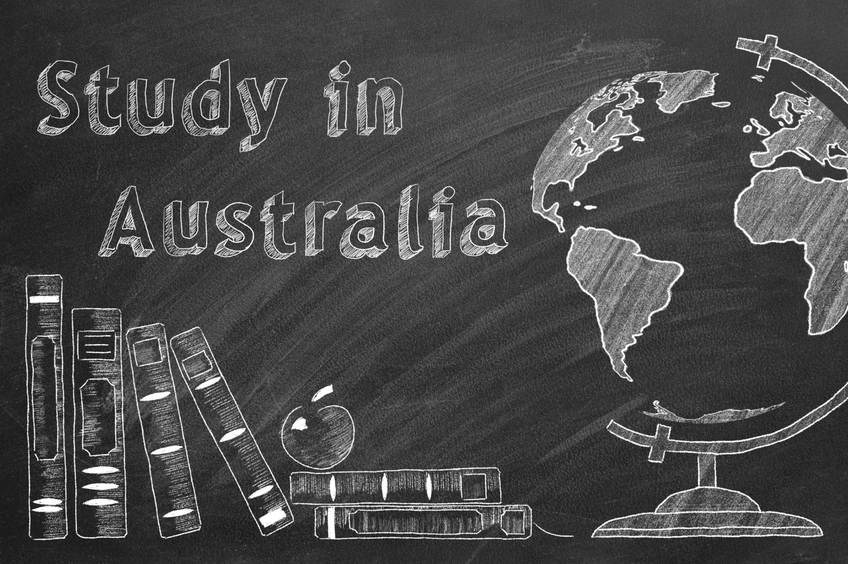

**International student commencements to be capped at 270,000 next year**

Education Minister Jason Clare this week unveiled a proposal to limit international enrolments across universities and vocational training to 270,000 places in 2025, like pre-pandemic levels but about 20 per cent lower than recent peaks.

The proposed limits are subject to the government's bill passing parliament.

Education Minister Jason Clare has announced his much-anticipated overall limit for international students starting in 2025, with individual caps to be set for providers.

The decision was announced as a part of a wider attempt to crack down on claims of exploitation in the international education sector, with the government also underlining the need to free up homes as Australia's rental crisis continues.

Speaking in May during his federal budget speech, Treasurer Jim Chalmers said international student enrolments had outpaced the creation of dedicated student housing, putting pressure on rents and making "finding housing harder for everyone".

**Export industry worth billions**

International education is one of Australia's largest exports, worth $48 billion in 2023 according to Australian Bureau of Statistics (ABS) figures.

And fees paid by international students are the second-largest source of income for tertiary institutions, behind government funding.

The international education market is big business, particularly in Australia. As the government moves forward with the most significant crackdown on the sector in decades, we look at just how massive the industry really is.

The University of Sydney tops the list for international student enrolments, and international student fees also made up 47 per cent of its revenue in 2022.

That's followed by the University of Queensland (34 per cent of revenue), the University of Melbourne (33 per cent), Monash University (31 per cent) and the University of New South Wales (31 per cent).

Ngaire Bogemann, president of the National Union of Students, [told the ABC](https://www.abc.net.au/news/2024-08-28/international-student-cap-splits-tertiary-education-sector/104277446) this week that the government's proposed cap was "a slammed door in the face of hundreds of prospective students.""Some 741,000 international students in Australia are an important part of our diverse campus communities," the student union leader said.

"The federal government has essentially told them that they aren't welcome here."

The proposed cap has split the higher education sector, with some metropolitan universities set to lose out on students while smaller regional and suburban universities can ramp up their international enrolments.

Leaders at some city-based universities have raised concerns that prospective students will simply seek other courses overseas.

"We know that international students don't choose a country, they choose a university and a course, and if they don't get into that course, they'll go to some other country potentially," said Margaret Sheil, deputy chair of Universities Australia and vice-chancellor of the Queensland University of Technology.

**Students may look elsewhere**

Jakarta-based education agent Janto Sugiharto So said he was concerned that properly "qualified" students will ditch Australia for other countries like the UK, US or Singapore.

The US and UK do not have caps on international student numbers and some education agents are encouraging students to study there instead.

Mr Sugiharto So said he "didn't mind" the government's decision, as long as it's "only for the short-term".

"But the government must know what the next step is," he said.

**[International students face steep rents for single rooms](https://www.abc.net.au/news/2024-06-02/international-students-paying-500-dollars-for-shared-room/103908418)**

For those who choose to live in student housing, rents for a single room can often be more than the price of a whole apartment, with some international students saying the prices are "insane".

Mr Sugiharto So said "the best solution" to solve long-term problems in the sector would be to build more international student accommodation.He said he supported the idea of cracking down on the exploitation of international students but is concerned the cap proposal is an overly broad, blunt policy.

"I'm afraid they are putting a limit for all students, including the intelligent and qualified ones, so they don't get a chance," he said."The system becomes 'first come, first serve'."You have to think about the plan of study for months or even years [in advance of applying]."

**Students still want to study in Australia**

Some of Australia's most prestigious universities [have already sent out](https://www.abc.net.au/news/2024-08-29/international-student-offers-in-doubt-under-caps/104280660) offers of enrolment to international students for 2025, despite uncertainty over the number of places allowed.

At least 11 institutions had made offers before Mr Clare announced the caps on Tuesday.And several universities have told the ABC they are unsure whether they will have to rescind their offers to study next year.

Each university will be subject to an individualised international student cap, and the government has said it will take up to two weeks for those numbers to be finalised.



**[International student uni offers could be rescinded under caps](https://www.abc.net.au/news/2024-08-29/international-student-offers-in-doubt-under-caps/104280660)**

Some of Australia's most prestigious universities have offered 2025 places to international students that are now uncertain under new caps to be imposed by the federal government.

But despite the uncertain outlook caused by the policy proposal, both Mr Suryawijaya and Ms Heriadi said they remained excited to study in Australia in the future.

"I think studying at a university in Australia is just the same as studying at other universities in the world which offer high-quality education," Mr Suryawijaya said.

The Indonesian citizen said he held out hope the federal government would review the policy.

"Perhaps they can increase the quota because there is a big appetite from international students to study in Australia," he said.

Ms Heriadi said she doesn't think she will regret her decision to study in Australia.

"I think the money I pay will be worth it," Ms Heriadi said.

"Because I won't only be paying for the education, but also for the environment and quality of life in Australia."